**User Guide for Merch Fox**

*Created By*: **Alexis Richard**

*Created At*: **April 4, 2017**

Overview

This project consists of 2 sub-systems – one is chrome extension and another is merch fox backend side. So every user will be able to search Tee Shirts on Amazon.com with MerchFox chrome extension, save them into database via REST API hosted on backend side.

Also every user is able to retrieve his / her search results in options page of chrome extension and products page in backend side. And they can save (mark as important) products in options page and unsave (mark as not important). Once products marked as important, users will see them in “Your products” page in back end side.

1. **Authentication**

Every user should have his/her account on MerchFox, so don’t forget to register your email and password.

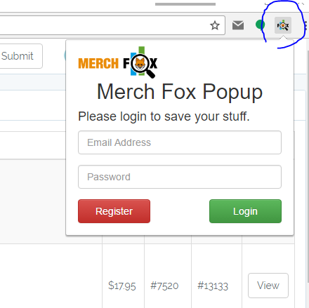

Once you click the browser icon highlighted in the above screenshot, MerchFox extension popup will appear. It’s the initiative you should start with and don’t hesitate to write your email and password if you have account on <http://184.73.108.215>. But if you don’t and have never been there, you just click “Register” button. It will lead you to register page of MerchFox.

I believe that it should not be painful for you to register / login to MerchFox - <http://184.73.108.215> and just back to extension popup to register with chrome extension. It’s almost done and you are ready to go with this extension.

1. **Search Products on Amazon automatically**

Once you are authenticated, you should be able to see “Start Now” button with keyword input box in popup as following.

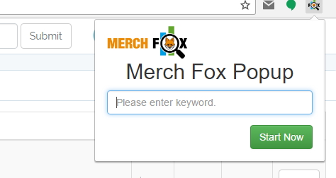

You can enter any keyword like “baseball”, “grandson” or whatever you want to search by. But you are able to keep blank if you want to search Tee shirts fully, so just click “Start Now” button.

Then the extension would start its magic stuff to open a tab to grab search results and 5 tabs to research product detail pages. So don’t worry about the 6 tabs created automatically because those will be closed when the stuff is done. Also you can never mind the tabs created by extension and keep doing anything you want.

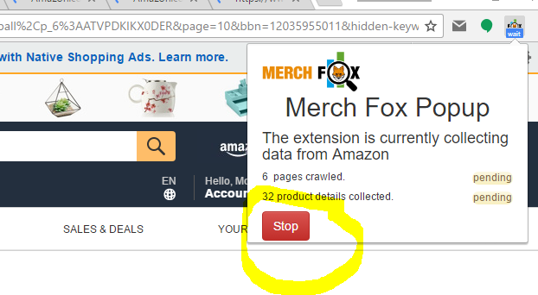

But if you don’t like the extension working or want to restart the searching, you can stop it anytime by clicking the red “Stop” button you can see in the above screenshot and restart.

Anyhow, the extension’s automatic stuff will be terminated after it checks the last product pulled from amazon’s search results page. Then you will be able to research products by keywords.

1. **Brief introduction to workflow**

If you had done a search with this extension, you should have had something in database for you and been able to see them in options page of chrome extension, which can be visible when you select “Options” in context menu opening after right click on chrome extension icon. In this page, you can search with whatever you type in, and sort table by any column you want. Please have a look at the below screenshot.

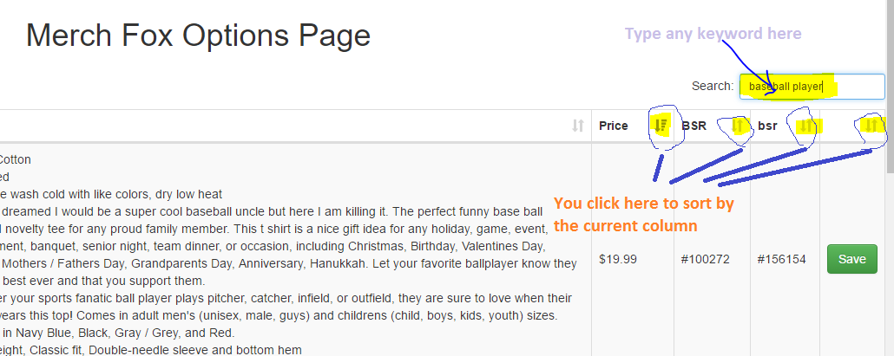

During the research, you will find some interesting and important products or keywords. Then you can save the product by one click to a button and cancel the save by clicking again.

Just click “Save” button to save the product, and “Unsave” button to cancel the saved product. You can see the saved products in saved products page. The page is <http://184.73.108.215/items>.

In this page, you can paginate to find a product and check again. Save / Unsave can be done as following.

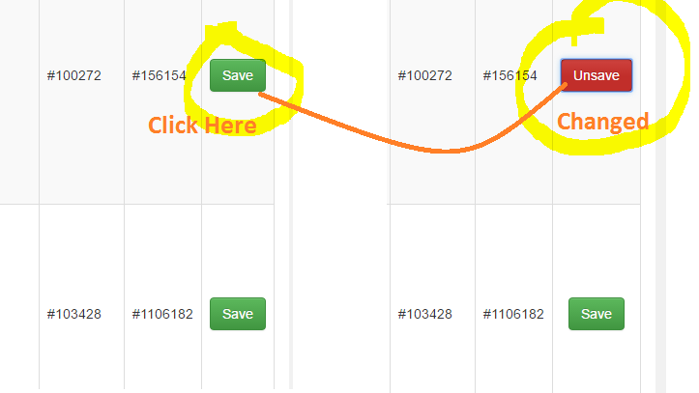

Now you can find the saved product in the saved products page as mentioned above. So looks like that.

